Surfin’ Creatives

# Project: Influencer Performance Database

The objective was to develop an influencer database, including contact information and engagement metrics. Then conduct data analysis on influencer performance metrics using advanced Excel and other influencer measuring tools to identify trends, insights and opportunities for optimization. Creation and optimization of influencer marketing products offered by Surfin Creatives.

Users can shift between tabs by clicking on the links provided in the first row of every sheet.   
Step-by-Step Guide:

1. **Tab 1: Details**   
   The first sheet of the workbook includes all the details and social metrics of the influencers which are mapped for all the pivot charts and tables in other sheets. The column headers in this sheet are:  
   Influencer Identity (IID)  
   For eg. SS001A  
   ‘SS’ – Surfin Creatives  
   001 – Id number allocated to the influencer  
   ‘A’ – First letter of the influencer’s respective genre  
     
   Full name, Username  
   Personal Details – Age, Gender, Email, Contact Number  
   Creator Type   
   Start value – No. of followers beginning from given value  
   End value – No. of followers ending till the given value  
     
   Genre – A style or category of art, music, or literature  
   Performance Metrics – Followers, average likes, engagement rate, visual, sound quality, overall appeal  
   Payout/ Video  
     
     
     
     
     
   Post Format – Reels or Images  
   Contract Information  
   Previous Collaborations  
   Performance Score – Mapped from the Ratings sheet  
   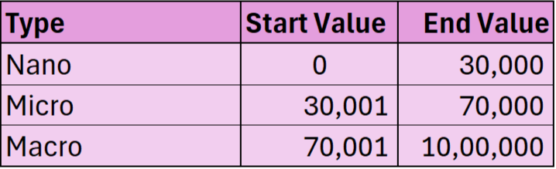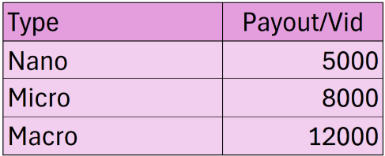
2. **Tab 2: Rating**  
   This sheet is mapped entirely to the “Details” sheet with the help of the Lookup function. Here, the final score of the influencers is calculated through a set logic. The logic was developed after studying several articles, blogs and research papers on influencer rating systems. The logic is provided in a tabular form in the “Mapping” sheet.  
   **Note: Details and Rating sheets must be protected and given limited edit access as the data in this sheet is crucial for all tables and charts including the dashboard.**
3. **Tab 3: Packages Offered**This sheet showcases pre-designed packages for the clients, and it is an interactive sheet. Here, as per the client’s needs, a budget and goal of their campaign is selected with the help of data validation and the required influencers are automatically listed and top influencers are suggested. As per the budget, the expected gross profit is also calculated and shown. Refer to the picture for budgets and goals offered.  
   **Note: The tables in this sheet from column ‘M’ to ‘AA’ are hidden and must not be edited as they consist of complex functions which when hindered could cause error in the entire sheet.**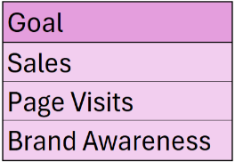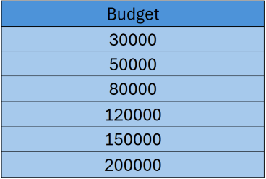
4. **Tab 4: Sorted**This sheet consists of 3 tables which are sorted in descending order with respect to engagement rate, followers and score. Along with this, 2 slicers have also been provided to filter the tables with respect to creator type and genre. This enables us to see the top influencers and can be filtered according to the client’s needs.
5. **Tab 5: Comparison**Users can select up to 5 influencers and compare them on aspects of creator type, followers, average likes, engagement rate, overall content rating, score. The dynamic chart below the comparison table visualizes the comparison data and shows the selected influencers’ sum of followers and their performance.
6. **Tab 6: Demographics**This dashboard visualizes the demographics of influencers, including their age and location distributions. It features a bar graph displaying the number of influencers in different age groups, ranging from 18 to 37, grouped in 5-year intervals. Additionally, it shows the average age of the influencers. All these visualizations are connected to the slicers provided in this sheet.
7. **Tab 6: Insights**This sheet consists of the final dashboard which will be presented to our clients and other end users. It includes charts of genre and type wise share of influencers, followers wise engagement rate, type wise performance, payout wise engagement rate and post format. Slicers of genre and type of creator can also be used to filter the charts for a better understanding of influencer’s representation.
8. **Tab 7: Mapping**    
   This sheet consists of all the logics based on which the rating for the social metrics of the influencers has been built upon. There are 4 interval tables and the rating for social metrics is mapped to these tables. The logic behind the rating system has been built on the basis of several articles, blogs and with the assistance of Chat GPT.  
     
     
     
   For eg.  
      
   **Start value** – No. of followers beginning from given value  
   **End value** – No. of followers ending till the given value  
   **Bracket** – Followers falling between the given numbers will be assigned their respective bracket which will be their rating for that particular social metric.  
     
     
     
     
     
     
     
     
     
     
   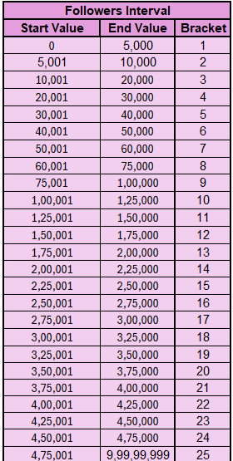

**NOTE:**

1. All the sheets which include the working of pivot charts in the dashboard are hidden. Unhide the sheets to view them.
2. Do not add extra rows or columns in any sheet as this may affect the formulas in the same or other sheets.
3. Tab3: Packages Offered may show some errors if made changes, make sure the formulas in the working tables (hidden) and displayed tables have “Row(B1)” in their formula.
4. The Slicers may be connected to graphs and tables of other sheets. Therefore, make sure to clear all filters before moving on to the next sheet.
5. If any columns are added in between other columns to the “Details”sheet, do check the ratings sheet as it might hinder the data left or right based on where the new sheet has been inserted. If not rectified, the performance score will be incorrect.